**Kubernetes Cluster Upgrade**

**Control plane upgradation:**

1. See which is the version your cluster is currently on (run on controlplane),
   1. **Kubeadm version**
   2. **Kubelet --version**
   3. **Kubectl version**

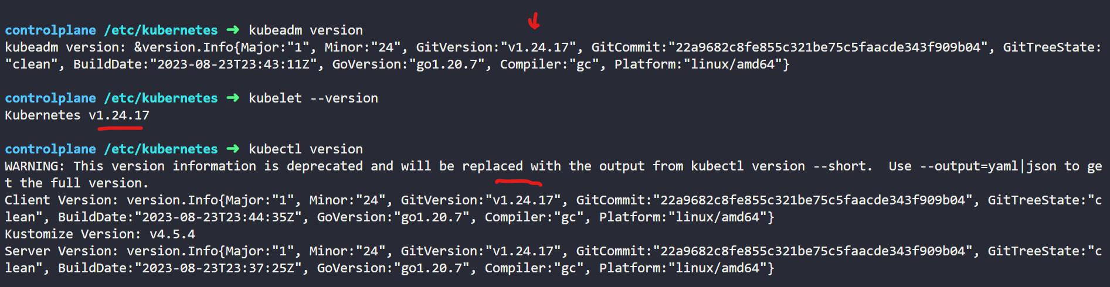

1. To check the next version you can upgrade to,
   1. **sudo kubeadm upgrade plan**

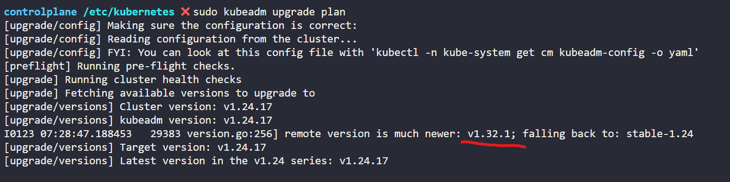

1. Now you need to update the repo from which kubeadm fetches the version,
   1. **sudo nano /etc/apt/sources.list.d/kubernetes.list** 🡪 then change the version
   2. **sudo apt update**

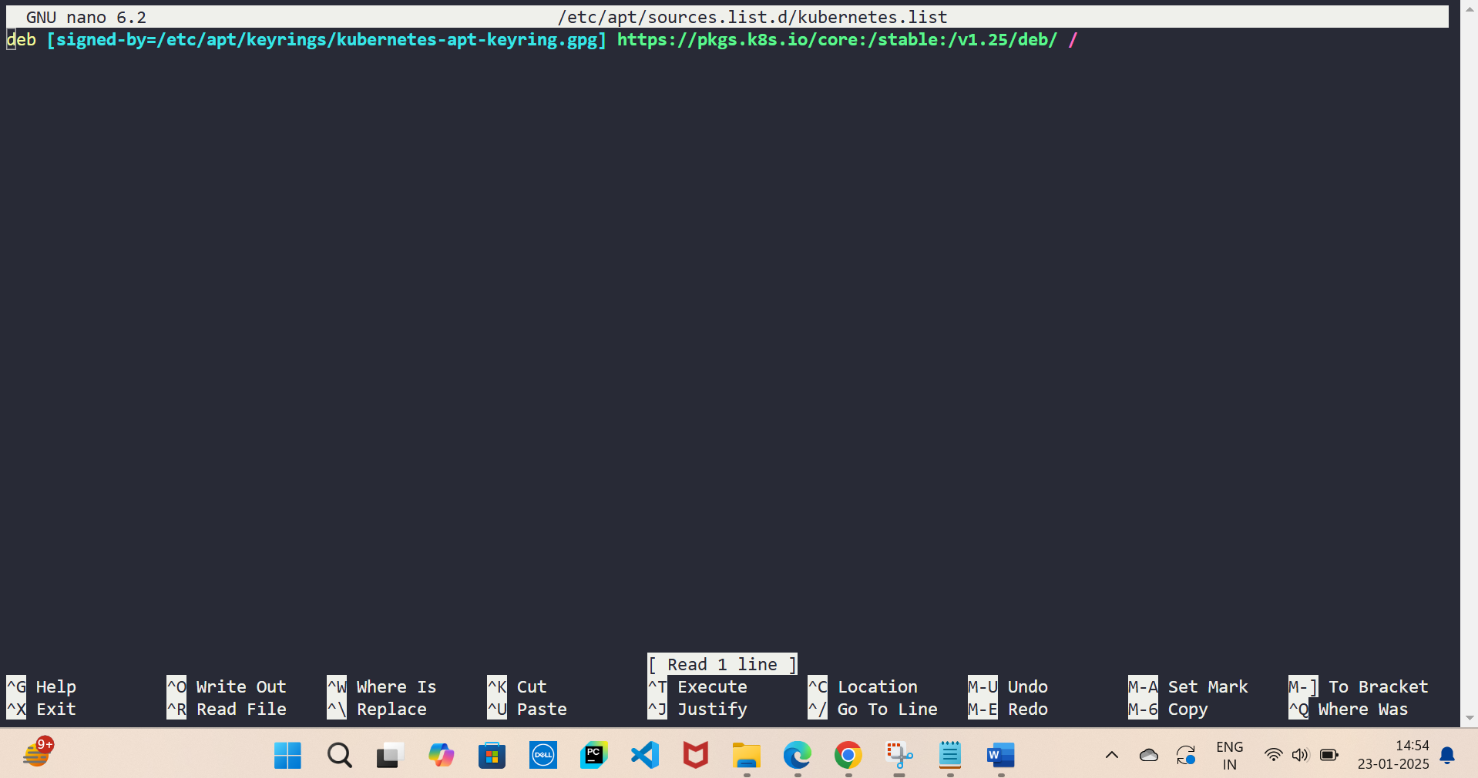

1. Note: 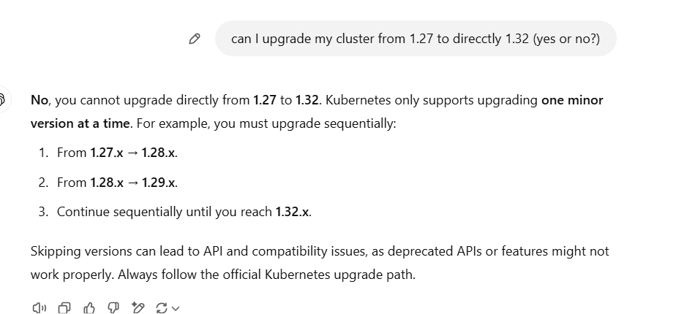
2. Now, run below command & you will see kubernetes has recognised that it will change the minor version
   1. **apt-cache madison kubeadm**

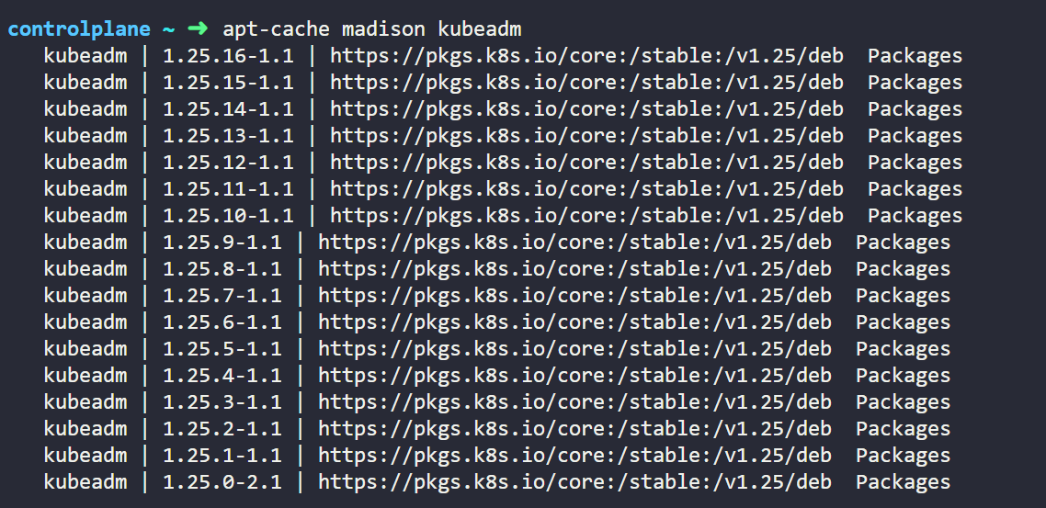

1. Now let us upgrade kubeadm,
   1. **apt-mark unhold kubeadm && apt-get update && apt-get install -y kubeadm='1.25.16-1.1' && apt-mark hold kubeadm** (always use the latest version, as we have got in the above image)

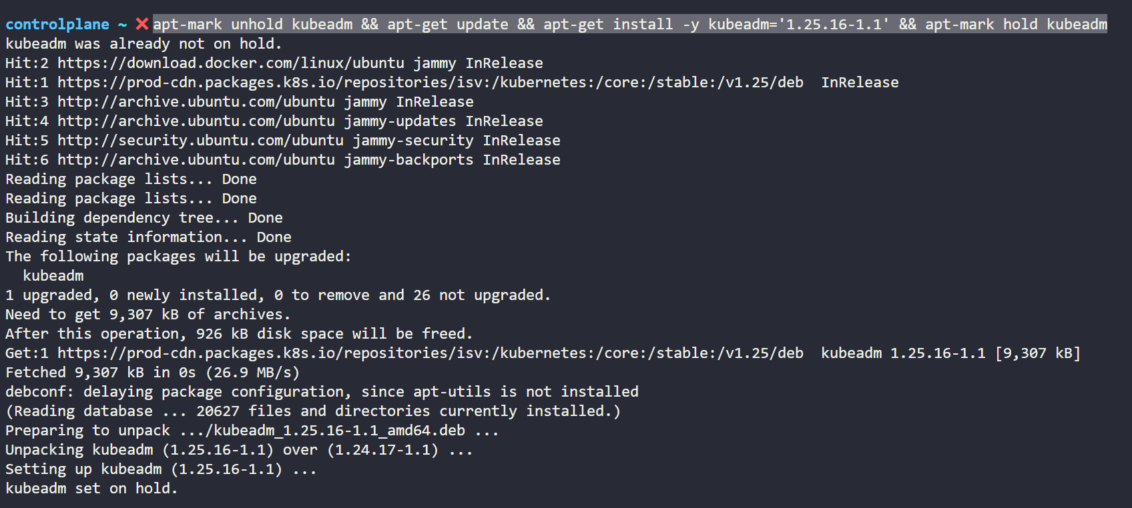 

1. Now its time to upgrade the rest of controlplane components,
   1. **kubeadm upgrade plan**
   2. **sudo kubeadm upgrade apply v1.25.16**

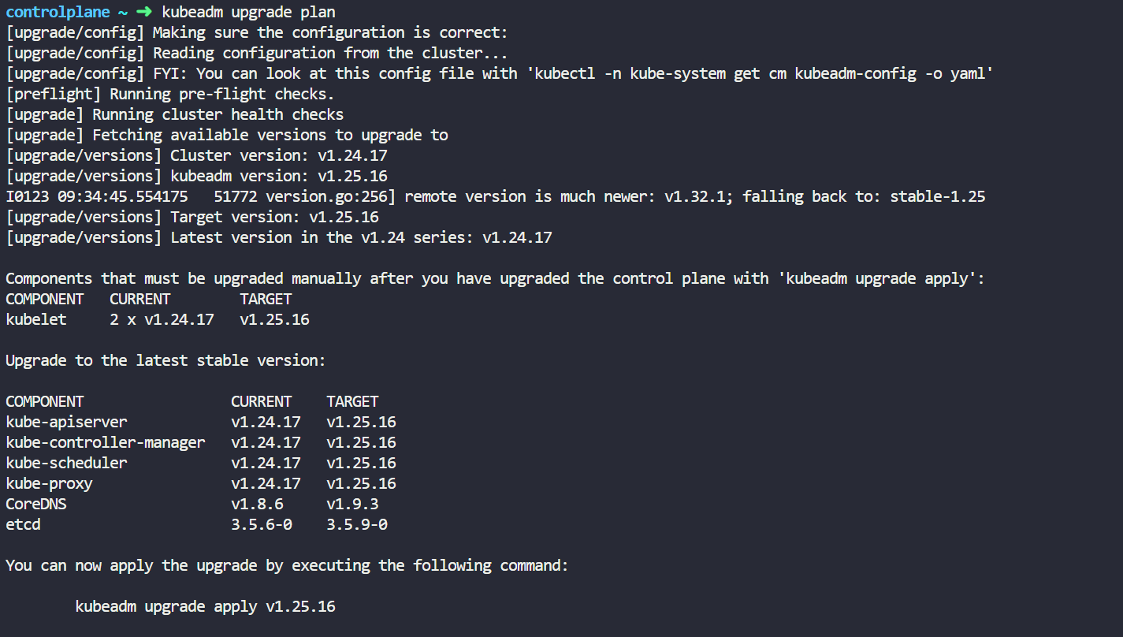

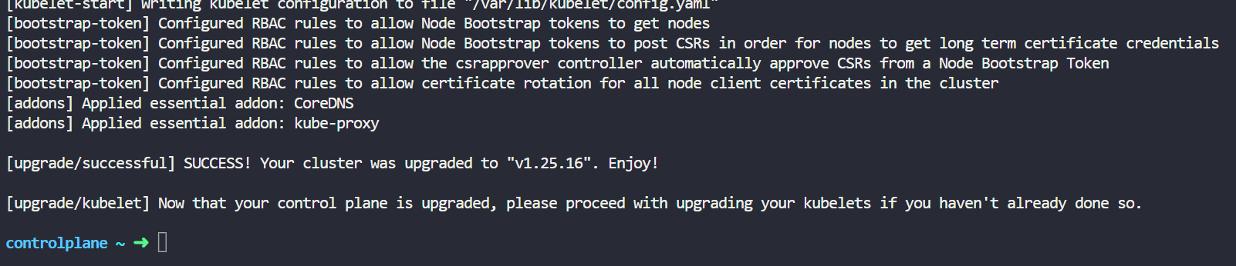

1. Now lets upgrade the kubelet.
   1. **kubectl drain controlplane --ignore-daemonsets**
   2. **apt-mark unhold kubelet kubectl && apt-get update && apt-get install -y kubelet='1.25.16-1.1' kubectl='1.25.16-1.1' && apt-mark hold kubelet kubectl**
   3. **sudo systemctl daemon-reload**
   4. **sudo systemctl restart kubelet**
   5. **kubectl uncordon controlplane**

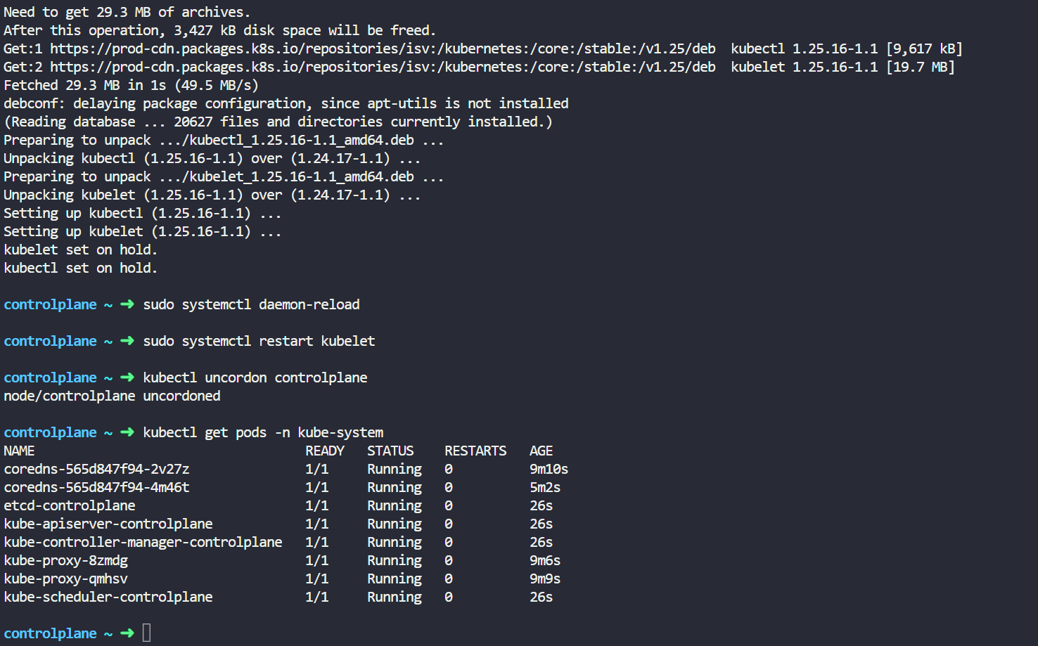

1. Voila! Every thing on your control plane is now upgraded

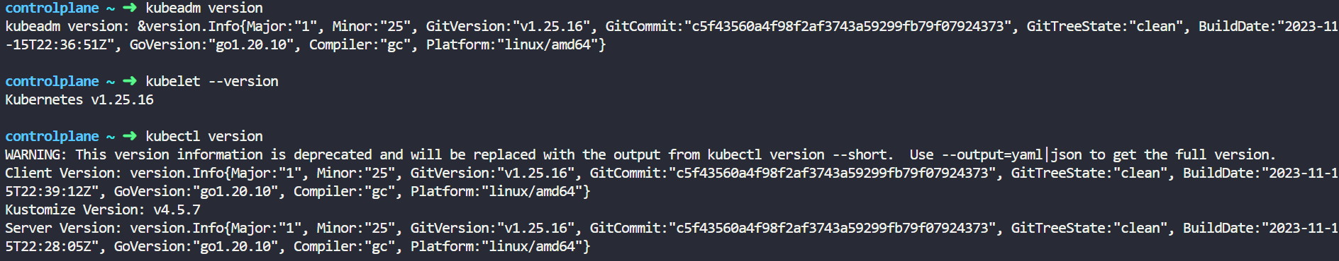

1. Now if there are other control planes just use below command and it will be automatically upgraded.
   1. **sudo kubeadm upgrade node**
   2. **(and rest of the command in point 8)**

**Worker Nodes Upgradation:**

1. Ssh to the node
   1. Ssh node01

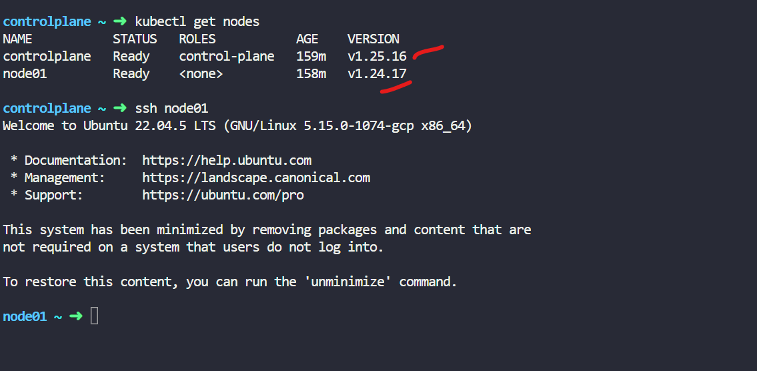

1. Till point 6 in above section, everything is same. Follow the same
2. Now let us update kubelet & kubectl,
   1. **sudo kubeadm upgrade node**
   2. **kubectl drain node01 --ignore-daemonsets** 🡪 (this needs to be executed on controlplane)
   3. **apt-mark unhold kubelet kubectl && apt-get update && apt-get install -y kubelet='1.25.16-1.1' kubectl='1.25.16-1.1' && apt-mark hold kubelet kubectl**
   4. **sudo systemctl restart kubelet**
   5. **sudo systemctl daemon-reload**
   6. **kubectl uncordon node01** 🡪 (this needs to be executed on controlplane)
   7. **kubectl get nodes**

